## **Supplement: Updating Atom to Handle Markdown**

Atom is a cross-platform plain text editor. These instructions for using Markdown in Atom come from this site: <https://adamtheautomator.com/convert-markdown-to-html/>

### Atom

Another great editor that supports many languages is [*Atom*](https://atom.io/). Atom also comes with packages, that when installed, extend its features further. One of these packages is the markdown-preview, which gives Atom the ability to save markdown content to HTML. Best of all, markdown-preview is already installed by default!

The first step to convert Markdown to HTML is to open your Markdown document in Atom. Then toggle the Markdown preview by pressing the CTRL+SHIFT+M keyboard shortcut. Another way to toggle the Markdown preview is from **Packages —> Markdown Preview —> Toggle Preview**.

Once the preview pane shows up, right-click on the preview and click **Save as HTML**, and save the file in your preferred folder. Refer to the demonstration below.

*Convert Markdown to HTML using Atom*

Below, you can see what the HTML formatted file looks like when exported using Atom. You might recognize that the appearance is similar to how GitHub displays Markdown contents.

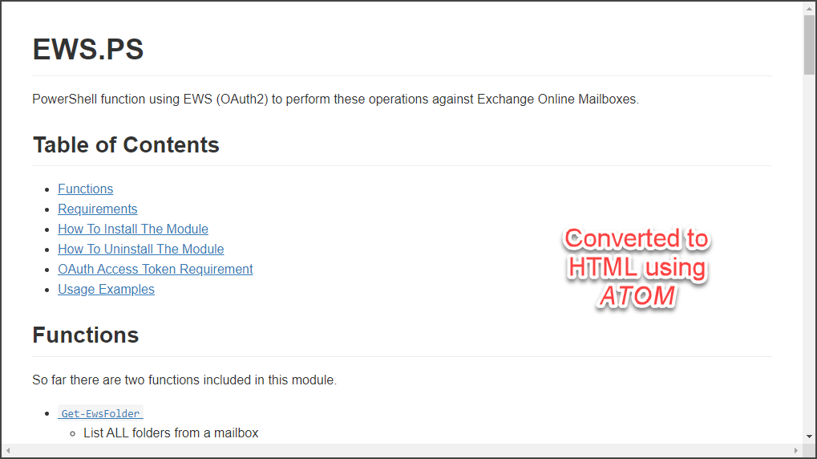*HTML output format using Atom*